Step-by-Step Guide
- Access Google AI Studio

- Explore the Dashboard

- Use the Prompt Playground

- Try Your First Prompt

- Customize Model Settings

- Generate an API Key (Optional)

HOW TO USE GOOGLE AI STUDIO FOR BEGINNERS

A Step-by-Step Guide to Getting Started with Gemini AI
TUTORIAL
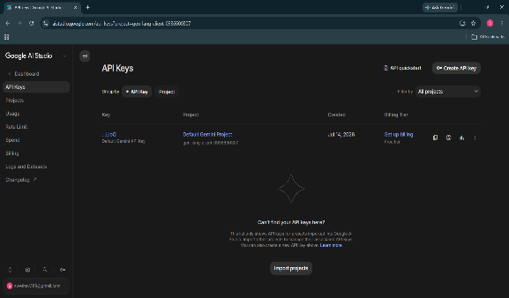
- Open your web browser and visit https://aistudio.google.com
- Sign in using your Google account.
- Accept the terms if prompted.
- You will be directed to the Google AI Studio dashboard.


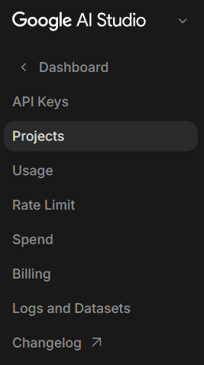

What is Google AI Studio?
Google AI Studio is a free, web-based platform developed by Google that allows users to experiment with Gemini AI models. It enables you to create prompts, test responses, and build AI-powered applications without requiring complex setup.

- The dashboard provides access to the Prompt Playground, documentation, API keys, and settings.
- Spend a few minutes exploring the interface to become familiar with the available tools.

What You Can Do

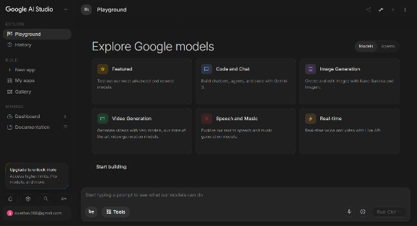
- Open the Prompt Playground.
- Choose a Gemini model.
- Enter a prompt in the text box.
- Click Run to generate a response.
- Modify your prompt and compare different outputs.







Overview of the Steps

- Access Google AI Studio
- Explore the Dashboard
- Use the Prompt Playground
- Try Your First Prompt
- Customize Model Settings
- Generate an API Key (Optional)

Test and refine prompts
Analyze text and images
Generate API keys for integration
Generate and explain code
Chat with Gemini AI models

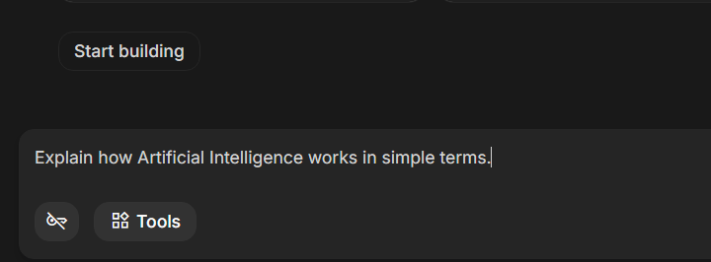
- Enter a simple prompt such as:
- "Explain how Artificial Intelligence works in simple terms."
- Review the response and experiment with different questions to observe how the model responds.

- A Google Account
- Stable Internet Connection
- Basic Computer Knowledge
- Curiosity to Explore AI

Prerequisites

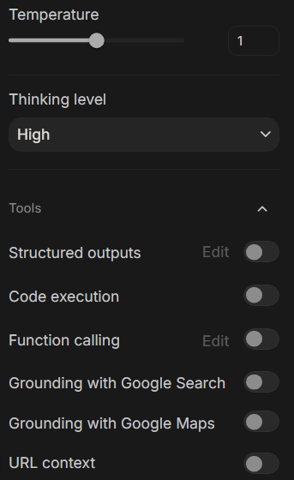

- You can adjust model parameters like,
  - Temperature,
  - Top P,
  - Maximum Output Tokens.
- Experiment with these options to understand how they affect response quality and creativity.


Tip
Take time to explore and experiment. The more you try, the better you will understand how Gemini works!
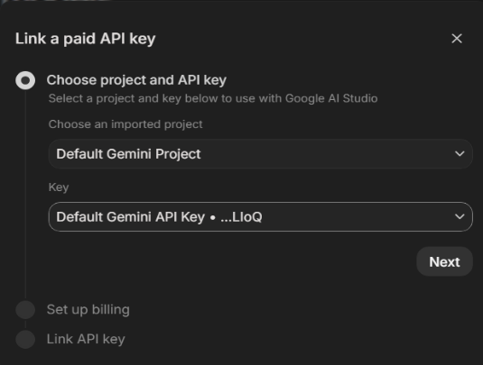
If you plan to build AI-powered applications:
- Open the API Keys section.
- Click Create API Key.
- Copy and securely store your key.
- Never share your API key publicly.

Conclusion
Google AI Studio offers an easy and accessible way to explore Google's Gemini AI models. With its intuitive interface and powerful features, beginners can quickly learn prompt engineering, test AI capabilities, and begin developing intelligent applications with confidence.

